Step: 1
Create Repository on GitHub: GitAndJenkinsAssignment-1
Step: 2
- Create folder in local drive GitAndJenkinsAssignment-1
Step: 3 Clone Repository
- git clone https://github.com/chaudharytamar/GitAndJenkinsAssignment-1.git
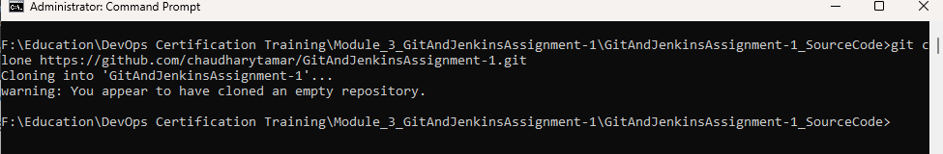
- Paste downloaded code inside GitAndJenkinsAssignment-1 cloned folder
Step: 4 Add code
- git add .
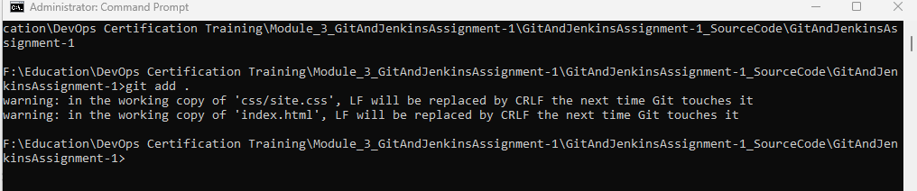
Step: 5 Commit Code to Main Branch
- git commit -m "Source code commit in main branch"
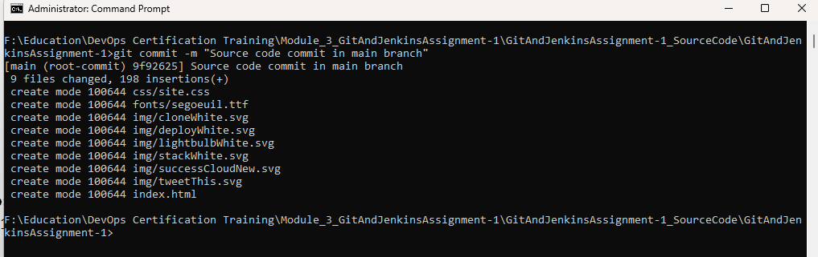
Step: 6 Push Code to Main Branch
- git push origin main

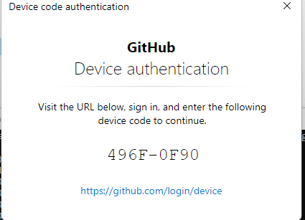

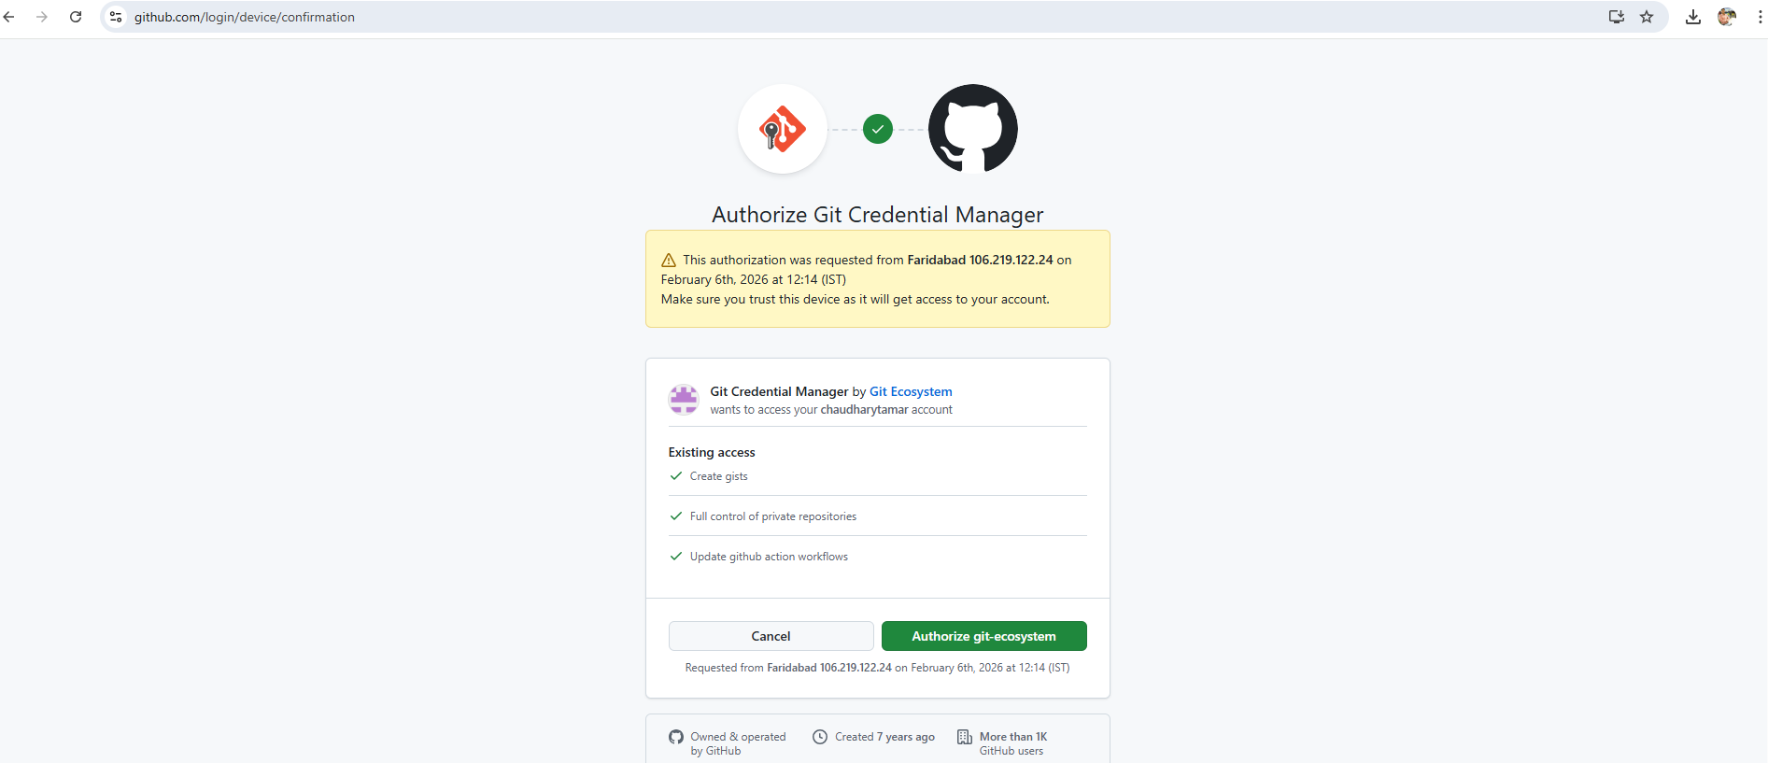

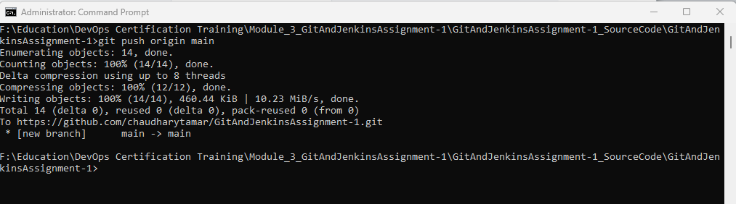

Step: 7 Create Two Separate Branches and checkout
git checkout -b Kane-FeatureBranch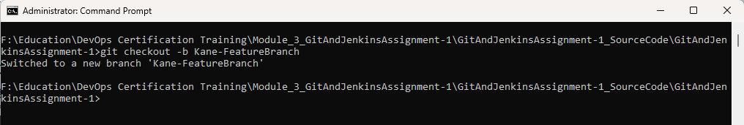
git checkout main
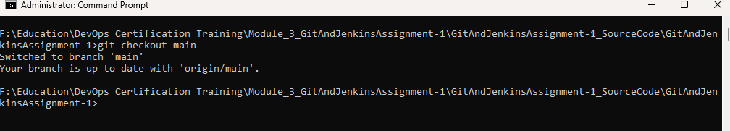

git checkout -b Harry-FeatureBranch
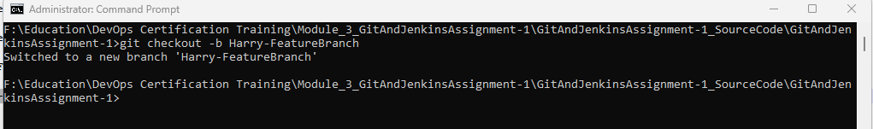

Step: 8 Add Code by Developer (Kane)
- git add .
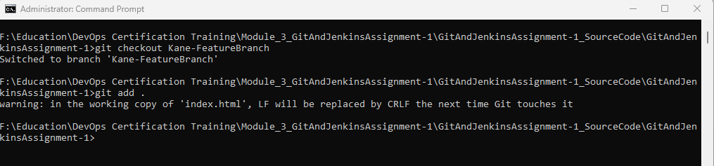

Step: 9 Commit Code by Developer (Kane)
- git commit -m "Code commit by Kane"
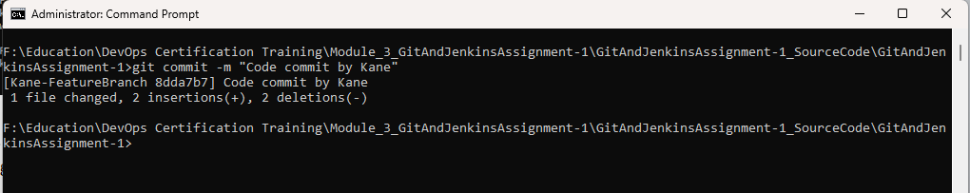

Step: 10 checkout Harry-FeatureBranch
git checkout Harry-FeatureBranch
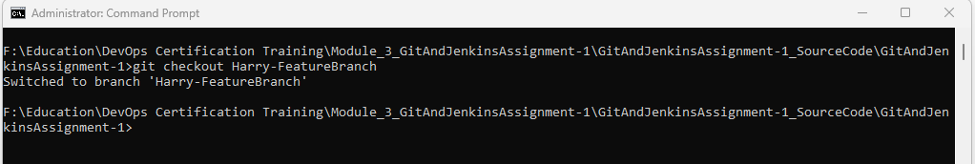

Step: 11 Add Code by Developer (Harry)
git add .
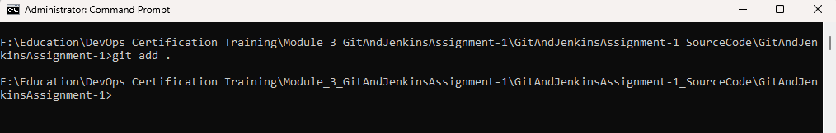

Step: 12 Code Commit by Developer (Harry)
git commit -m "Code commit by Harry"
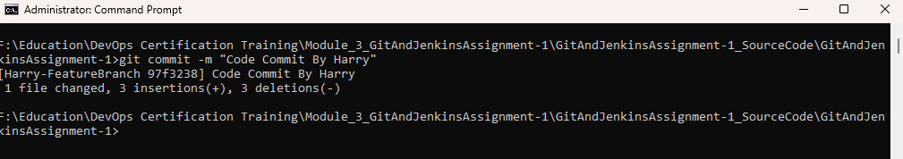

Step: 13 Code Commit by Developer (Kane)
Merge Kane-FeatureBranch into master git checkout main
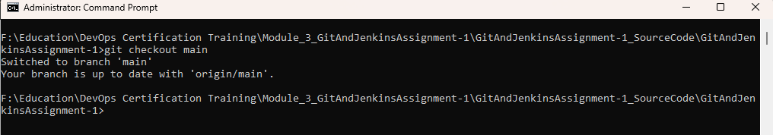

git merge Kane-FeatureBranch
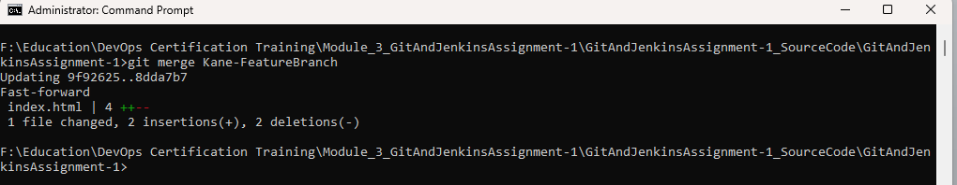

Step: 14 Merge Harry-FeatureBranch into master (Conflict Occurs)
git merge Harry-FeatureBranch
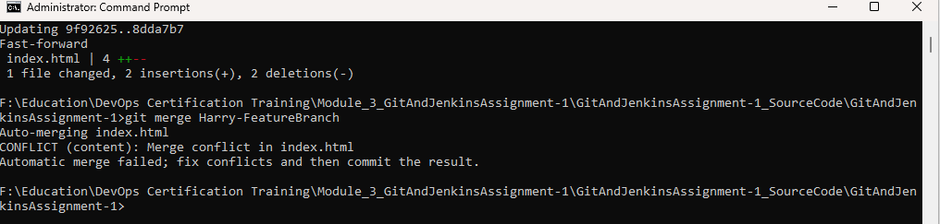

Resolve Conflict Using git mergetool
git mergetool
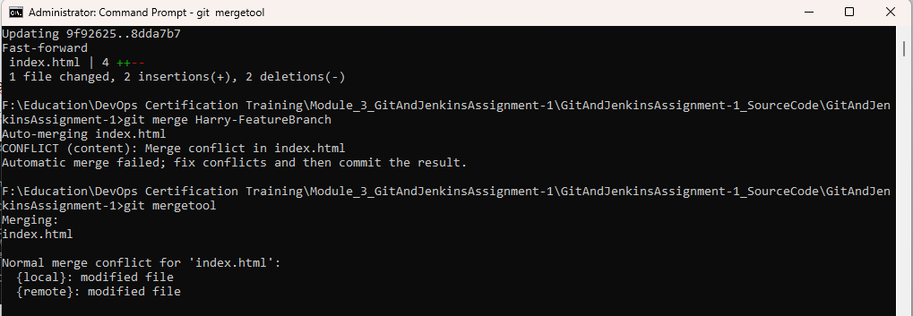

Step: 15 Complete the Merge
git add .
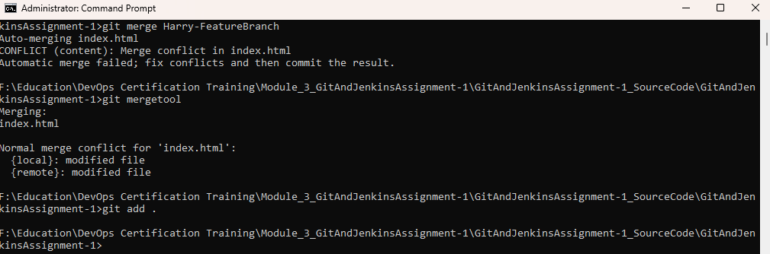

git commit -m "Resolved merge conflict using git mergetool"
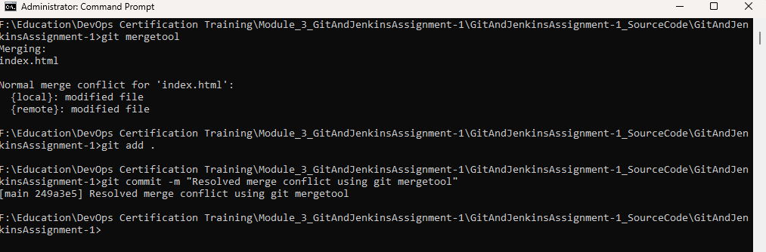

git push origin main
